System Requirements Statement (SRS) –

Docpulse - Meet Your Doctor

**Group No.: G64**

**Roll No. Name**

223127 Omkar Shivaji Mohite

223103 Kunal Kisan Lokhande

1. **Introduction**
2. **Functional Requirements**
   * 2.1 Patient Module
   * 2.2 Doctor Module
   * 2.3 Admin Module
3. **NON-FUNCTIONAL REQIREMENTS**

# Introduction

# Document Purpose

The purpose of our Project “Docpulse - Meet Your Doctor System” is to automate the process of getting medical treatment and health checkup in a way that saves both time and effort. It manages all the information of patient and doctors. The project is developed at administrative end and thus only the administrator is guaranteed to have access to everything. The purpose of this project is to create a web application that reduces the manual efforts of looking for a doctor and booking appointments.

# Goals of the project

The main objective of this project is to build a website which will provide user facility to book appointments online with specialist doctor in user chosen locality. A user can look for a doctor based on user’s requirement, doctor’s specialties and location, and then pick a time slot available and book the appointment. The aim of our project is to bridge the gap between a patient and a doctor.

# Functional Requirements Overview

System consists of four modules described as below.

1. Patient/User Module
2. Doctor Module
3. Admin Module

# 1. Patient/User Module

* Patient/User can register and update his own account.
* Patient/User can search Doctor according to need.
* Patient/User can view Doctors’ information.
* Patient/User can view/book Doctors’ appointments.
* Patient/User can check status of current appointment.
* Patient/User can cancel appointment.
* Patient/User can check previous appointments (History)
* Patient can pay Appointment fees online
* Patients can get different updates on Email, Mobile SMS

# 2. Doctor Module

* Doctor can register and update his own account.
* Doctor can create/Update appointment slot.
* Doctor can Check/Update Active appointment status.
* Doctor can view appointment history.
* Doctor can check patient’s treatment history.
* Doctor will get patients registered appointment alert on Email and Mobile SMS
* Doctor will get different updates on Email and Mobile SMS
* Doctor can accept Appointment payment online

# 3. Admin Module

* System should provide all function to admin how to handle the System.
* What are the Patient and Doctor are using this System and are they authorized.
* Could able to maintain/know all the record/history.
* Register/delete/block Doctor.
* Register/delete/block Patient.
* Register/delete/block Staff.

**Functional Description**

The Account part of Docpulse - Meet Your Doctor System has three modules which are divided -- processes described as below.

|  |  |  |
| --- | --- | --- |
| **No** | **SRS requirement ID** | **Description** |
| **2.1** | **Patient Module** | |
| **2.1.1** | **F1** | **Registration Process** |
| **2.1.2** | **F2** | **Login Process** |
| **2.1.3** | **F3** | **Forgot Password Process** |
| **2.1.4** | **F4** | **Change Password Process** |
| **2.1.5** | **F5** | **Update Account Process** |
| **2.1.6** | **F6** | **Search Doctors** |
| **2.1.7** | **F7** | **Book Appointment** |
| **2.1.8** | **F8** | **Check Appointment Status** |
| **2.1.9** | **F9** | **Cancel Appointment** |
| **2.1.10** | **F10** | **View Appointment History** |
| **2.1.11** | **F11** | **Patients pay app fees online** |
| **2.1.12** | **F12** | **Diff updates on Email, SMS** |
| **2.2** | **Doctor Module** | |
| **2.2.2** | **F13** | **Login Process** |
| **2.2.3** | **F14** | **Forgot Password Process** |
| **2.2.4** | **F15** | **Reset Password Process** |
| **2.2.5** | **F16** | **Active Appointment Process** |
| **2.2.6** | **F17** | **Create Slots Process** |
| **2.2.7** | **F18** | **Update Profile Process** |
| **2.2.8** | **F19** | **Cancel Appointment Process** |
| **2.2.9** | **F20** | **View Appointment History Process** |
| **2.2.10** | **F21** | **Show Todays Slots** |
| **2.2.11** | **F22** | **Accept payment online** |
| **2.2.12** | **F23** | **Diff alerts on SMS, Email** |
| **2.3 Admin Module** | | |
| **2.3.1** | **F24** | **Login Process** |
| **2.3.2** | **F25** | **New Doctor Registration Process** |
| **2.3.3** | **F26** | **Patient List Process** |
| **2.3.4** | **F27** | **Doctor List Process** |
| **2.3.5** | **F28** | **Generate Report Process** |
| **2.3.6** | **F29** | **Manage Account Process** |

* **Patient Module**
* Patient is the user of System who can check doctor according to location, specialization.
* He is also able to book the appointment of available doctor.
* **Registration Process**
* Docpulse - Meet Your Doctor System compels to create the account for appointment booking. So, the System should provide the function which makes Patients create new account.
* When Patient creates new account, the function demands information described as below.
* Login information
* Contact Details
* Login information

The Login information consists of some items described as below

* UID Auto – Generated
* User Name
* Password
* First Name
* Last Name
* E-mail address
* Date of Birth
* Gender
* Blood Group
* All items are compulsory demanded.
* Email
* The Email should be unique. If the email corresponds with not case-sensitive to other which is previously registered, the email should not be registered as an account.
* Password
* The Password has constraints which makes the Password consists of more than or equal 8 and less than or equal 16 characteristics including characters described as below.
* Numeric figure (at least one)
* Capital alphabet (A-Z) (at least one)
* Small alphabet (a-z) (at least one)
* Special character (#, $, %, &, etc.) (at least one)
* The password is masked by dummy characters. The re-entering Password is demanded.
* The password must be encrypted in Docpulse - Meet Your Doctor (online appointment) System.
* Contact Details
* The Contact Detail consists of some items described as below
* Area
* City
* State
* Contact Number
* All items are compulsory demanded.
* Address
* Address should be filled.
* The city and state should be selected from options.
* **Login Process**
* Docpulse - Meet Your Doctor System always compels user authentication for using web application.
* The user authentication demands Email and Password. The Email and the Password should be checked in two ways.
* First, The Email and the Password should be existed and correct.
* If The Email and the Password are not equal to what the user has registered, the user authentication cannot be provided.
* Second, Email should be available.
* The Administrator can decide whether the Email is available or suspended – Refer to the SRS of the Admin part.
* If patient is rejected, user authentication is not provided for System user.
* **Forgot Password Process**
* When System user lost their Password, the recovery method should be provided by Docpulse - Meet Your Doctor System.

The recovery method is described as below.

* First, System user enters their Email for Docpulse - Meet Your Doctor System.
* Next, Docpulse - Meet Your Doctor System will send OTP on the registered Email.
* Only when the Answer is correct, farmer get the new password by E-mail which also has been registered since when the Account was created.
* Only when OTP entered is match then user will able to change password.
* The new password is manually entered by patient.
* Of course, the new password should consist of more than or equal 8 and less than or equal 16 characteristics including at least a numeric figure, a capital alphabet, a small alphabet, and a special character.
* **Change Password Process**
* When patient wants to change their Password, the measure should be provided by Docpulse - Meet Your Doctor System.
* Therefore, System should provide the function which is available after getting the patient authentication.
* The function demands the current password and the new password.
* Of course, the new password should consist of more than or equal 8 and less than or equal 16 characteristics including at least a numeric figure, a capital alphabet, a small alphabet, and a special character.
* The current password and the new password are masked by using dummy characters.
* The new password is demanded to enter twice to avoid a typing error.
* Only when the current password is correct, patient could change their Password
* When the current password is changed into new password, System compels user authentication again.
* **Update Account Process**
* Docpulse - Meet Your Doctor System should provide the function which makes the account updated for patient.
* The patient can update the information as described below
* User information
* The User information

The updatable items as described below.

* Contact Number
* Area
* City
* State

All items are compulsory demanded, but updating is optional.

* **Search doctor**

After login user can search for a doctor based on

* Location
* Specialization

If user select location as a criterion, then the list of all doctors of respective location will get displayed.

If user will search for the doctor without selecting the criteria (location or specialization) or user select specialization as a criterion without selecting the location, then System will give the message that user must select location to get list of doctors.

* **Book appointment**

After getting the list of doctors according to location and specialization patient can select the particular doctor.

After selecting the doctor, all the slots will be shown to the patient. The slots before the login time of patient and slots which are already booked will not be shown to patient. Patient can see only the slots which are available for booking.

Patient can book appointment according to the available slots of the respective doctor.

* **Check Appointment Status**

After successfully booking an appointment, the patient can check appointment status.

* **Cancel Appointment**

After successfully booking an appointment if patient wants to cancel the appointment, *Cancel Appointment* option is provided to patient.

* **View Appointment History**

Patient could see the information of all the previous appointments according to date select for the history.

* **Doctor Module**

* **Login Process**
* Docpulse - Meet Your Doctor System always compels Doctor authentication before using itself except when a new account is successfully created.
* The user authentication demands Email and Password. The Email and the Password should be checked in two ways.
* First, The Email and the Password should be existed and correct.
* If The Email and the Password are not equal to what the user has registered, the user authentication cannot be provided.
* Second, Email should be available.
* The Administrator can decide whether the Email is available or suspended – Refer to the SRS of the Admin part.
* If user is rejected, user authentication is not provided for doctor.
* Only when the two checks are successfully completed, Doctor can be placed on respected page.
* The “Doctor Home Page” provides some items described as below.
* A trigger to logout
* A trigger to Reset Password
* A trigger to Active Appointments
* A trigger to Create slots
* A trigger to Update profile
* A trigger to Cancel Appointments
* A trigger to View Appointments History
* A trigger to Show todays slots
* **Forgot Password Process**
* When Doctor lost their Password, the recovery method should be provided by Docpulse - Meet Your Doctor System.

The recovery method is described as below.

* First, Doctor enters their Email for Docpulse - Meet Your Doctor System.
* Next, Docpulse - Meet Your Doctor System demands the Answer which has been registered since when the Account was created.
* Only when the Answer is correct, Doctor gets the new password by E-mail which also has been registered since when the Account was created.
* The new password is manually entered by doctor.
* Of course, the new password should consist of more than or equal 8 and less than or equal 16 characteristics including at least a numeric figure, a capital alphabet, a small alphabet, and a special character.
* If the Answer is not correct, otherwise, the correct Answer is demanded for doctor again.
* In that case, Of course, Doctor could not get the new password.
* **Reset Password Process**
* Doctor can login using credentials given by the admin after successful registration.
* But for privacy doctor can reset password using Reset Password process.
* After reset password doctor will have to login by using new password for every time.
* The function demands the current password and the new password.
* Of course, the new password should consist of more than or equal 8 and less than or equal 16 characteristics including at least a numeric figure, a capital alphabet, a small alphabet, and a special character.
* The current password and the new password are masked by using dummy characters.
* The new password is demanded to enter twice to avoid a typing error.
* Only when the current password is correct, Doctor could change their Password.
* When the current password is changed into new password, Docpulse - Meet Your Doctor System compels Doctor authentication again.
* **Active Appointments Process**
* Doctor can able to see all the active appointment for a day.
* **Create Slots process**
* Doctor can create slots according to the availability.
* Doctor must provide following details to create slots.
* Start Date
* End Date
* Start Time
* End Time
* Slot duration in minutes
* Break time
* Holidays
* All items are compulsory demanded.
* **Update Profile Process**
* Docpulse - Meet Your Doctor System should provide the function which makes the account updated for doctor.
* The information Doctor could update is described below.
* Contact Number
* Area
* City
* State
* Languages
* Consultation fee
* Qualification
* Specialization
* All items are compulsory demanded, but updating is optional.
* **Cancel Appointment**

• Doctor can cancel particular appointment if required.

* **View Appointment History**

• Doctor can view all appointments history.

* **View Todays Slots**

• Doctor can view all the slots which are available for booking appointments.

* **Admin Module**

**•** Administratorshould be responsible for following activities**.**

* **Login Process**
* Docpulse - Meet Your Doctor System always compels user authentication before using itself except when a new account is successfully created.
* The user authentication demands Email and Password. The Email and the Password should be checked as -
* The Email and the Password should be existed and correct.

If The Email and the Password are not equal to what the admin has registered, the admin authentication cannot be provided.

* **Add Doctor (Registration)**

* Admin can create the new account for doctor by verifying all the information given by the doctor via email.
* When Patient creates new account, the function demands information described as below.
* If doctor wants to create account, he should send all the following details to the admin by email:
* Details:

The details information consists of some items described as below

* First Name
* Last Name
* Email
* Area
* City
* State
* Date of Birth
* Gender
* Username
* Contact Number
* Languages known
* Qualification
* Specialization
* Fees
* All items are compulsory demanded.
* Admin will verify all the details and create the account for doctor.
* Admin will send first login credentials to doctor (email and password).

Password sent by admin is in the form firstname@123.

* **View Patient List**

• Admin should be able to see all the patient list according following criteria:

* All registered patients
* Location wise
* Doctor wise
* According to appointment date
* **View Doctor List**

• Admin should be able to see all the doctor list according following criteria:

* All registered doctors
* Location wise
* According to registration date of doctor
* **Generate Report**

• Admin should able to see all the records from any users.

• Admin will generate daily report of enrolment of doctors and patients.

• Admin will generate Monthly report of enrolment of doctors and patients.

• Admin will generate report of number of attended patients by doctor on daily and monthly basis.

• Admin will generate report of appointments taken by patients on daily and monthly basis.

* **Accounts Management**

• Admin should able to manage all the accounts (doctors and patients) with following activities,

1. Enable accounts

2. Disable accounts (Admin can disable account for temporary or permanently if the community guidelines are not followed by doctor or patient)

* **Non-Functional Requirement**
  + Characteristic:
    - * UI should be localized with English-Marathi Language.
      * Platform should be secure, scalable, maintainable
  + Security:
    - * will implement Role based security to access content from Remote place.
      * System will provide secure communication between payment gateway applications (SSL)
      * System will expire session maintained for each user after 15 minutes.
      * System will not keep any sensitive data on user’s device.
      * Users’ information would protect.
      * All servers where System deployed would have been protected using firewall.
  + Safe:
    - * System will keep regular back up of data in incremental way.
      * System will be protected against malicious attack with proper cybersecurity rules.
      * System hosted servers would have been protected within restricted environment
  + Reliability:
    - * System will be always available 99.999%
      * System should have low downtime
      * System server would keep their availability using failover server
  + Scalability:
    - * System will provide consistent user experience irrespective of number users grow on particular events such as festival season,
      * Sale promotion. (Load balancing)
  + Modularity:
    - * System Web Application would be complex application due to its functionality expected.
      * System web Application would be composed using set of reusable modules.
  + Portability:
    - * System web application could be accessed from any personal device.
      * System will provide portable user interface using standard web technologies while building portal.
      * System web application could be deployed to any server Operating Environment.
      * System web application could be deployed to any Cloud such as Microsoft Azure or Amazon Web Service (AWS) or GCP
      * System web application could have been deployed to any other physical server or Virtualized server.
  + Compatibility:
    - * System could be installed on windows server, Linux server.
      * System will provide system browser compatible user interface

**ER-Diagram**

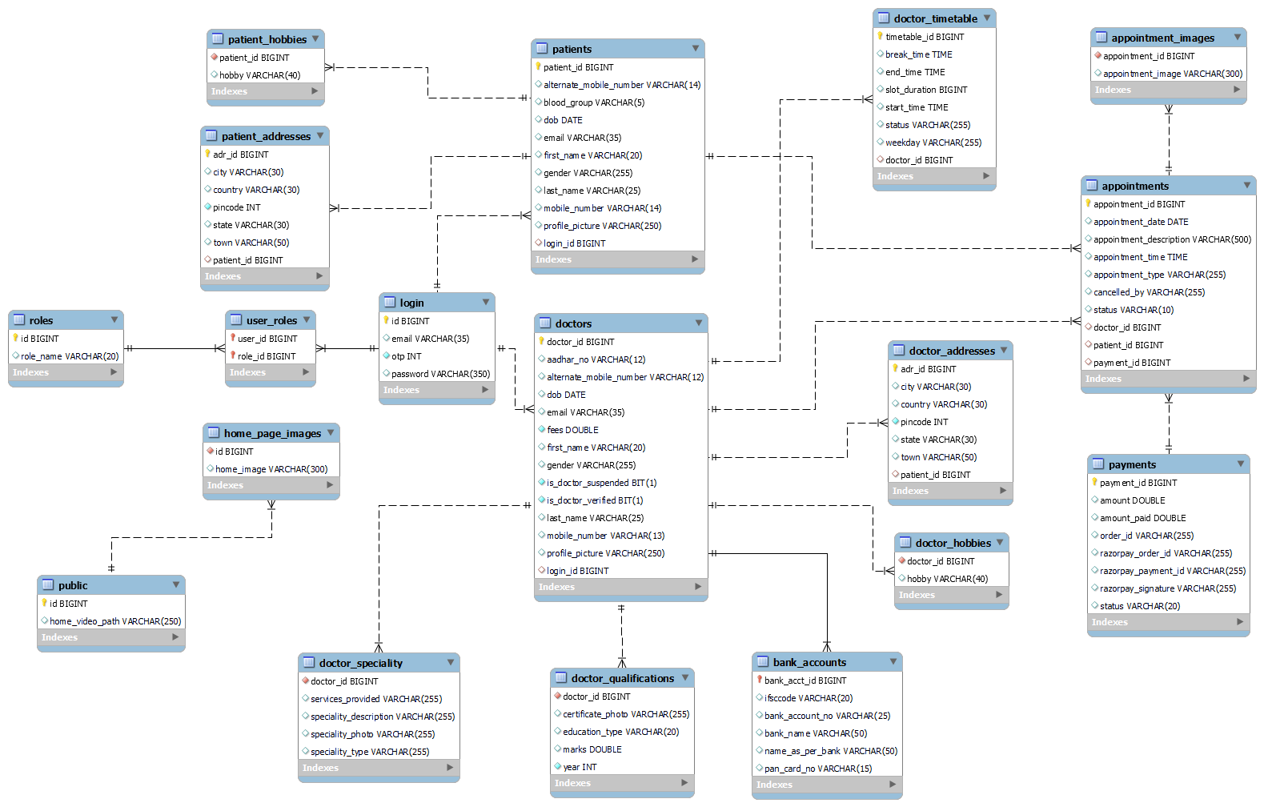

**Use Case Diagram**

**Admin:**

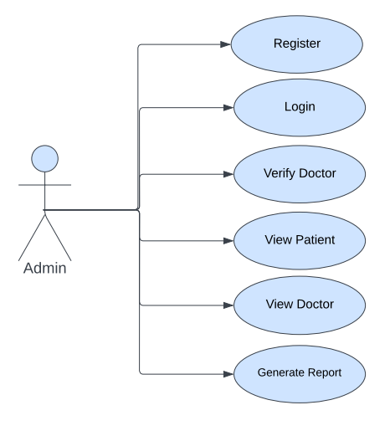

*Fig. Use case diagram for admin*

* In Admin use case diagram Admin is the Actor.
* Admin can handle following use cases:
* Login
* Add Doctor
* View Patient
* View Doctor
* Generate Report
* Manage Account

**Patient:**

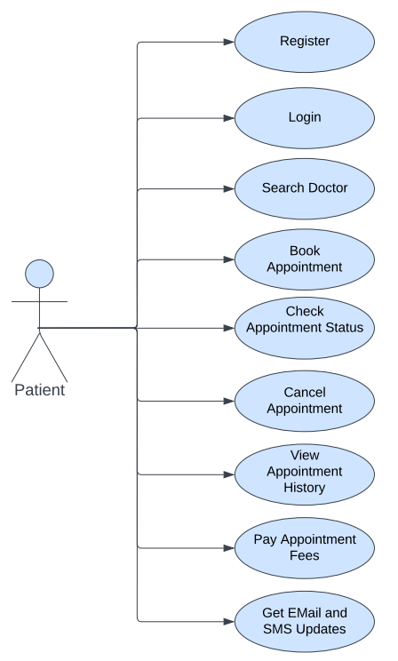

*Fig. Use case diagram for Patient*

* In Patient use case diagram Patient is the Actor.
* Patient can handle following use cases:
* Register
* Login
* Search Doctor
* Book Appointment
* Check Appointment Status
* Cancel Appointment
* View Appointment History

**Doctor:**

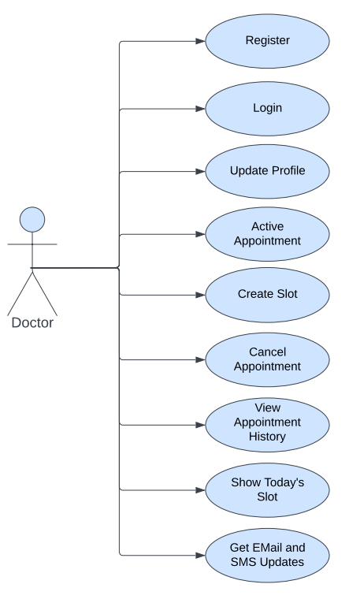

*Fig. Use case diagram for Doctor*

* In Doctor use case diagram Doctor is the Actor**.**
* Doctor can handle following use cases:
* Login
* Update Profile
* Active Appointment
* Create Slots
* Cancel Appointment
* View Appointment History
* Show Today's Slot

**Table Structure**

**Table :Patient Table**

|  |  |  |  |  |
| --- | --- | --- | --- | --- |
| Key Type/ Constraint | Column Name | Data Type | Length | Allow Null (1=Yes;0=No) |
| PK | patient_id | int |  | 0 |
|  | first_name | varchar | 30 | 0 |
|  | last_name | varchar | 30 | 1 |
|  | mobile_number | varchar | 14 | 0 |
|  | alternate_mobile_number | varchar | 14 | 0 |
|  | email | varchar | 35 | 0 |
|  | blood_group | varchar | 5 | 1 |
|  | dob | date |  | 1 |
|  | gender | varchar | 20 | 1 |
|  | profile_picure | varchar | 250 | 0 |
| FK | Login_id | bigint |  | 0 |

**Table : patient_addresses**

|  |  |  |  |  |
| --- | --- | --- | --- | --- |
| Key Type/ Constraint | Column Name | Data Type | Length | Allow Null (1=Yes;0=No) |
| PK | id | int |  | 0 |
|  | state_ | varchar | 30 | 0 |
|  | city | varchar | 30 | 0 |
|  | town | Varchar | 30 | 0 |
|  | country | Varchar | 30 | 0 |
|  | pincode | int |  | 0 |
| FK | patient_id | int |  | 0 |

**Table : patient_hobbies**

|  |  |  |  |  |
| --- | --- | --- | --- | --- |
| Key Type/ Constraint | Column Name | Data Type | Length | Allow Null (1=Yes;0=No) |
| PK | varchar_id | bigint |  | 0 |
|  | hobby | Varchar | 40 | 0 |

**Table : Login Table**

|  |  |  |  |  |
| --- | --- | --- | --- | --- |
| Key Type/ Constraint | Column Name | Data Type | Length | Allow Null (1=Yes;0=No) |
| PK | id | int |  | 0 |
| UK | username(email) | varchar | 35 | 0 |
|  | password | varchar | 35 | 0 |
|  | otp | int |  | 0 |

**Table : user_roles**

|  |  |  |  |  |
| --- | --- | --- | --- | --- |
| Key Type/ Constraint | Column Name | Data Type | Length | Allow Null (1=Yes;0=No) |
|  | user_id | bigint |  | 0 |
|  | role_id | bigint |  | 0 |

|  |  |  |  |  |
| --- | --- | --- | --- | --- |
| Key Type/ Constraint | Column Name | Data Type | Length | Allow Null (1=Yes;0=No) |
|  | id | bigint |  | 0 |
|  | role_name | varchar | 50 | 0 |

**Table : roles**

**Table : Doctor**

|  |  |  |  |  |
| --- | --- | --- | --- | --- |
| Key Type/ Constraint | Column Name | Data Type | Length | Allow Null (1=Yes;0=No) |
| PK | id | int |  | 0 |
|  | Aadhar_no | Varchar | 12 | 0 |
|  | email | varchar | 35 | 0 |
|  | first_name | varchar | 30 | 0 |
|  | last_name | varchar | 30 | 1 |
|  | dob | date |  | 1 |
|  | gender | varchar | 20 | 1 |
|  | mobile_number | varchar | 12 | 0 |
|  | Alternate_mobile_number | varchar | 12 | 0 |
|  | fees | int |  | 0 |
|  | profile_picure | varchar | 250 | 0 |
|  | is_doctor_suspended | varchar | 30 | 0 |
|  | is_doctor_verified | bit | 1 | 0 |
| FK | login_id | int |  | 0 |

**Table : doctor_addresses**

|  |  |  |  |  |
| --- | --- | --- | --- | --- |
| Key Type/ Constraint | Column Name | Data Type | Length | Allow Null (1=Yes;0=No) |
| PK | id | int |  | 0 |
|  | state_ | varchar | 30 | 0 |
|  | city | varchar | 30 | 0 |
|  | town | Varchar | 30 | 0 |
|  | country | Varchar | 30 | 0 |
|  | pincode | int |  | 0 |
| FK***** | doctor_id | int |  | 0 |

**Table : doctor_hobbies**

|  |  |  |  |  |
| --- | --- | --- | --- | --- |
| Key Type/ Constraint | Column Name | Data Type | Length | Allow Null (1=Yes;0=No) |
| PK | Doctor_id | bigint |  | 0 |
|  | hobby | Varchar | 40 | 0 |

**Table : doctor_speciality**

|  |  |  |  |  |
| --- | --- | --- | --- | --- |
| Key Type/ Constraint | Column Name | Data Type | Length | Allow Null (1=Yes;0=No) |
| PK | doctor_id | bigint |  | 0 |
|  | Services_provided | Varchar | 255 | **0** |
|  | Speciality_description | varchar | 255 | 0 |
|  | Speciality_type | varchar | 255 | 0 |
|  | Speciality_photo | varchar | 255 | 0 |

**Table : doctor_qualification**

|  |  |  |  |  |
| --- | --- | --- | --- | --- |
| Key Type/ Constraint | Column Name | Data Type | Length | Allow Null (1=Yes;0=No) |
| PK | doctor_id | bigint |  | 0 |
|  | Certificate_photo | Varchar | 255 | **0** |
|  | education_type | varchar | 20 | 0 |
|  | marks | double | double | 0 |
|  | year | int |  | 0 |

**Table : bank_account**

|  |  |  |  |  |
| --- | --- | --- | --- | --- |
| Key Type/ Constraint | Column Name | Data Type | Length | Allow Null (1=Yes;0=No) |
| PK | Bank_acct_id | bigint |  | 0 |
|  | ifsccode | Varchar | 20 | **0** |
|  | bank_account_number | varchar | 25 | 0 |
|  | bank_name | varchar | 50 | 0 |
|  | name_as_per_bank | varchar | 50 | 0 |
|  | pan_card_no | int | 15 | 0 |

**Table : Appointment**

|  |  |  |  |  |
| --- | --- | --- | --- | --- |
| Key Type/ Constraint | Column Name | Data Type | Length | Allow Null (1=Yes;0=No) |
| PK | appointment_id | int |  | 0 |
|  | appointment_date | date |  | 0 |
|  | appointment_time | time |  | 0 |
|  | appointment_description | varchar | 500 | 0 |
|  | appointment_type | varchar | 255 | 0 |
|  | status |  | 10 | 1 |
|  | cancelled_by |  | 30 | 1 |
| FK | payment_id | int |  | 1 |
| FK | doctor_id | int |  | 0 |
| FK | patient_id | int |  | 0 |

**Table : Doctor Timetable**

|  |  |  |  |  |
| --- | --- | --- | --- | --- |
| Key Type/ Constraint | Column Name | Data Type | Length | Allow Null (1=Yes;0=No) |
| PK | timetable_id | bigint |  | 0 |
| FK | doctor_id | time |  | 0 |
|  | Start_time | Time |  | 0 |
|  | End_time | Time |  | 0 |
|  | weekday | varchar | 255 | 0 |
|  | slot_duration | int |  | 0 |
|  | break_time | time |  | 0 |
|  | status | varchar | 255 | 0 |

**Table : Payments**

|  |  |  |  |  |
| --- | --- | --- | --- | --- |
| Key Type/ Constraint | Column Name | Data Type | Length | Allow Null (1=Yes;0=No) |
| PK | Patient_id | int |  | 0 |
| PK | Order_id | varchar | 20 | 0 |
|  | amount | number | 20 | 0 |
|  | amount_paid | number | 20 | 0 |
|  | status | varchar | 10 | 0 |
|  | razorpay_order_id | varchar | 100 | 0 |
|  | razorpay_payment_id | varchar | 100 | 0 |
|  | razorpay_signature | varchar | 100 | 0 |

**Table : appointment_images**

|  |  |  |  |  |
| --- | --- | --- | --- | --- |
| Key Type/ Constraint | Column Name | Data Type | Length | Allow Null (1=Yes;0=No) |
| PK | Appointment_id | int |  | 0 |
|  | image | varchar | 45 | 0 |